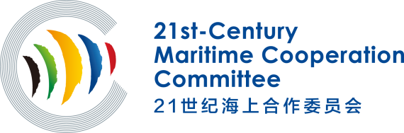
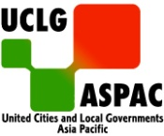

21st-Century Maritime Cooperation Committee
Questionnaire on Cooperation Intention among
Member Cities/Organizations

Name:_____________________________________________________
Department and Position:______________________________________

With the aim of giving full play to the advantages of the "21st-Century Maritime Cooperation Committee" (hereinafter referred to as the Committee) and also to better promote the exchanges and cooperation among members cities/organizations, this questionnaire is designed to have a better knowledge of the cooperation intentions of member cities/organizations as well as your opinions and suggestions on the Committee. Thank you in advance for your time to fill out this questionnaire. We will fully consider your valuable opinions and suggestions. Wish you all the best!

I Basic Information
- Country:_________________________________
- City/Organization:__________________________
- Basic Information of City(Population/Size/Location):
__________________________________________________________________________________________________________________________________________

II Cooperation Intention
- What is the leading economic industry in your city?
__________________________________________________________________________________________________________________________________________
- What kind of advantageous industries or projects that your city could share with other member cities/organizations?
__________________________________________________________________________________________________________________________________________
- What kind of industries or projects your city/organization wants to introduce most? (e.g. public service, infrastructure construction, education communication, environmental protection, cultural industry development projects)
__________________________________________________________________________________________________________________________________________
- What do you think of economic and trade as well as industry cooperation among member cities/organizations?
__________________________________________________________________________________________________________________________________________
- What do you think are the main problems and obstacles in cooperation among member cities/organizations？(e.g. lack of cooperative mechanism, lack of policy guidance, lack of initiative, high cost of cooperation)
__________________________________________________________________________________________________________________________________________
- What kind of cities/organizations do you intend to cooperate with? (Please describe its city size, location and characteristic industry.)
__________________________________________________________________________________________________________________________________________
- What areas your city/organization may look for economic and trade as well as industry cooperation with other cities/organizations?
__________________________________________________________________________________________________________________________________________
- What kinds of exchanges and cooperation do you hope to promote?
__________________________________________________________________________________________________________________________________________

III Opinions and Suggestions on the Committee
- How do you hope the Committee further promote the cooperation among member cities/organizations？
__________________________________________________________________________________________________________________________________________
- What kinds of activities do you hope the Committee to carry out? (e.g. forum and seminar etc.) What kinds of projects do you hope the Committee to initiate?
__________________________________________________________________________________________________________________________________________
- Does your city/organization have the intention of holding related activities launched by the Committee? If so, what kind of activities are you interested in?
__________________________________________________________________________________________________________________________________________
- What other advice and suggestions do you have for the Committee?
__________________________________________________________________________________________________________________________________________

Please kindly attach the brief introduction of your city/organization (some representative pictures of your city if possible) after filling out this questionnaire. More detailed information will be appreciated! Thank you!

Secretariat of 21st-Century Maritime Cooperation Committee
October, 2020

